**What goal will your website be designed to achieve?**

There are a lot of useful resources for people who play D&D online, there are also a lot of pre-existing applications with a similar function. The goal is generally to provide whatever information D&D Players need in a quick and efficient manner, as well as keep information readily available for when they are playing.

**What kind of users will visit your site? In other words, what is the demographic of your users?**

User would be anyone who is interested in D&D, but typically players of 5th Edition. It’s played by a variety of different individuals. Especially recently it’s become a very popular tabletop roleplaying game, so a lot of people could find the site useful if it is well polished enough.

**What data do you plan on using? You may have not picked your actual API yet, which is fine, just outline what kind of data you would like it to contain.**

Fortunately, <http://www.dnd5eapi.com> already has all of the information that I want to use for free. This API includes information for Classes, Class Features, Monsters, Spells. Within each category there is a large amount of information that can be referenced.

**In brief, outline your approach to creating your project (knowing that you may not know everything in advance and that these details might change later). Answer questions like the ones below, but feel free to add more information:**

[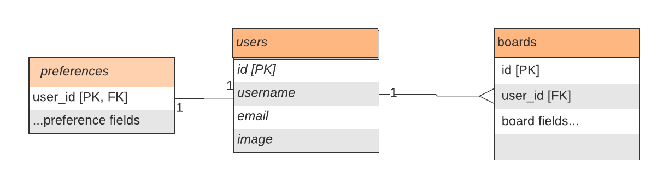](https://lucid.app/documents/edit/7073f5c7-188f-4588-98a3-a505892f2d35/0?callback=close&name=docs&callback_type=back&v=701&s=612)

At the moment I don’t know the limitations of how ‘free’ the API is. I don’t know if a large amount of traffic will be problematic, and there is a lot of information I haven’t fully looked through. Based on what I’ve seen there should be everything I need to at least prepare one of the features for the Capstone Project.

The only sensitive information will be the user information I’ll have for the application. Only users will be able to use the additional features which will be to make a sort of board that saves information that the player or DM using the application will need.